AIM:

The aim is to solve the missionaries cannibal problem using python program

Program:

from queue import Queue

class State:

def __init__(self, missionaries, cannibals, boat):

self.missionaries = missionaries

self.cannibals = cannibals

self.boat = boat

def is_valid(self):

if self.missionaries < 0 or self.cannibals < 0 or self.missionaries > 3 or self.cannibals > 3:

return False

if self.cannibals > self.missionaries > 0 or (3 - self.cannibals) > (3 - self.missionaries) > 0:

return False

return True

def is_goal(self):

return self.missionaries == 0 and self.cannibals == 0

def __eq__(self, other):

return self.missionaries == other.missionaries and self.cannibals == other.cannibals and self.boat == other.boat

def __hash__(self):

return hash((self.missionaries, self.cannibals, self.boat))

def get_neighbors(current_state):

neighbors = []

possible_moves = [(1, 0), (2, 0), (0, 1), (0, 2), (1, 1)]

for move in possible_moves:

new_state = State(

current_state.missionaries - move[0] * current_state.boat,

current_state.cannibals - move[1] * current_state.boat,

1 - current_state.boat

)

new_state_on_other_side = State(

current_state.missionaries + move[0] * (1 - current_state.boat),

current_state.cannibals + move[1] * (1 - current_state.boat),

1 - current_state.boat

)

if new_state.is_valid() and new_state_on_other_side.is_valid():

neighbors.append(new_state)

return neighbors

def breadth_first_search():

initial_state = State(3, 3, 1)

goal_state = State(0, 0, 0)

frontier = Queue()

frontier.put(initial_state)

came_from = {}

came_from[initial_state] = None

while not frontier.empty():

current_state = frontier.get()

if current_state.is_goal():

path = []

while current_state:

path.append(current_state)

current_state = came_from[current_state]

path.reverse()

return path

for next_state in get_neighbors(current_state):

if next_state not in came_from:

frontier.put(next_state)

came_from[next_state] = current_state

return None

def print_solution(path):

for t, state in enumerate(path):

print(f"Step {t + 1}:")

print(f"On the side {state.boat} - Missionaries: {state.missionaries}, Cannibals: {state.cannibals}")

print(f"On the other side {1 - state.boat} - Missionaries: {3 - state.missionaries}, Cannibals: {3 - state.cannibals}")

print()

if __name__ == "__main__":

solution_path = breadth_first_search()

if solution_path:

print("Solution found!")

print_solution(solution_path)

else:

print("No solution found”)

INPUT:

Side=1

Side=0

Side=0

Output:

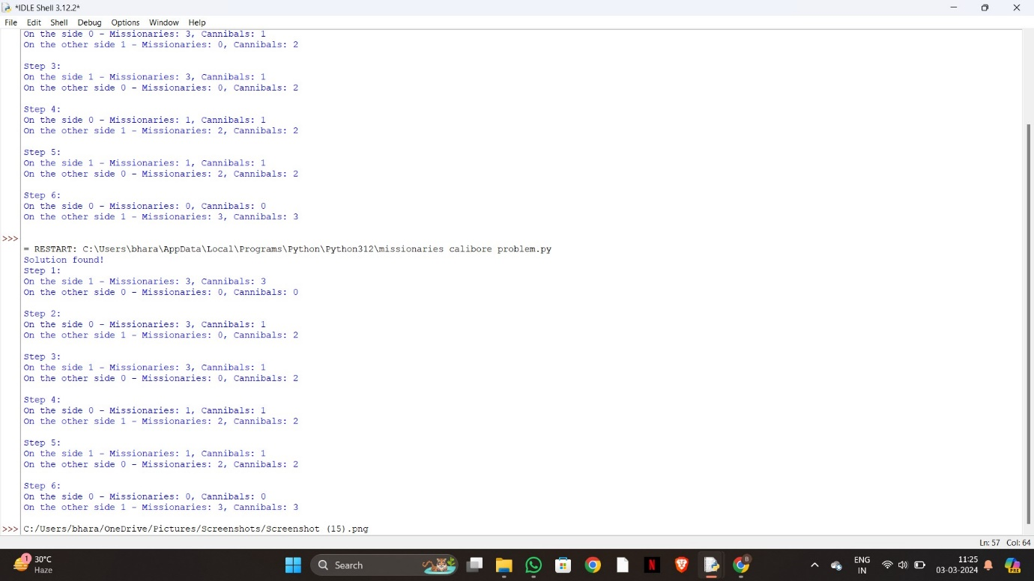

Result:

To solve the missionaries cannibal problem using python program is successfully completed